|  |  |
| --- | --- |
|  | **AIoT Korea Exhibition 2025**  Nov. 26(Wed) - Nov. 28(Fri), 2025 / COEX, Seoul, Korea |

|  |  |  |  |  |  |  |  |  |  |
| --- | --- | --- | --- | --- | --- | --- | --- | --- | --- |
| **1. Exhibitor information** | |  |  |  | |  | |  |  |
| **Company Name** |  | | | | | | | | |
| **Address** | **Zip Code ( - )** | | | | | | | | |
| **Tel** |  | | | | **Fax** | |  | | |
| **Website** | **www.** | | | | | | | | |
| **Contact Person** |  | | | | **Job position** | |  | | |
| **E-mail** |  | | | | **Direct number** | |  | | |



|  |  |  |  |
| --- | --- | --- | --- |
| **2. Booth type & Price Information** [1booth : 3mx3m= 9sq.m.] | | |  |
| **Booth Type** | **Raw Space**  (Min. size 2 booths) | **Shell Scheme Package**  (Min. size 1 booth) | |
| **Regular Rate** | USD 2,700 / 1booth | USD 3,000 / 1booth | |
| **Early-Bird discount** | USD 2,430 / 1booth | USD 2,700 / 1booth | |

**※ Early-bird Discount: until April 25, 2025.**

|  |  |  |  |  |
| --- | --- | --- | --- | --- |
| **3. Participation Fee for Exhibitions Space** | | | | |
| **Booth Type** | **Booth Quantity** | | **Total** | |
| **▪ Raw Space** |  | Booth(s) | USD |  |
| **▪ Shell Scheme Package** |  | Booth(s) | USD |  |

*※ VAT may apply depending on the exhibitor’s country*.

|  |
| --- |
| **4. Products to be exhibited** |
|  |
|  |

**5. Payment Schedule**

The Exhibitor agrees to the following payment Schedule :

- **The deposit**(50% of the total amount) should be paid **within 7 days**.

- **The remaining balance** should be paid no later than **September 26(Fri), 2025**.

|  |  |  |  |  |  |  |
| --- | --- | --- | --- | --- | --- | --- |
| **Name** |  | | **Title** |  | **Date** |  |
| **Authorized Signatory**  **& Company Stamp** | |  | | | | |

AIoT Korea Show Management Office l T. +82-2-555-7153 E. aiot@kiot.or.kr

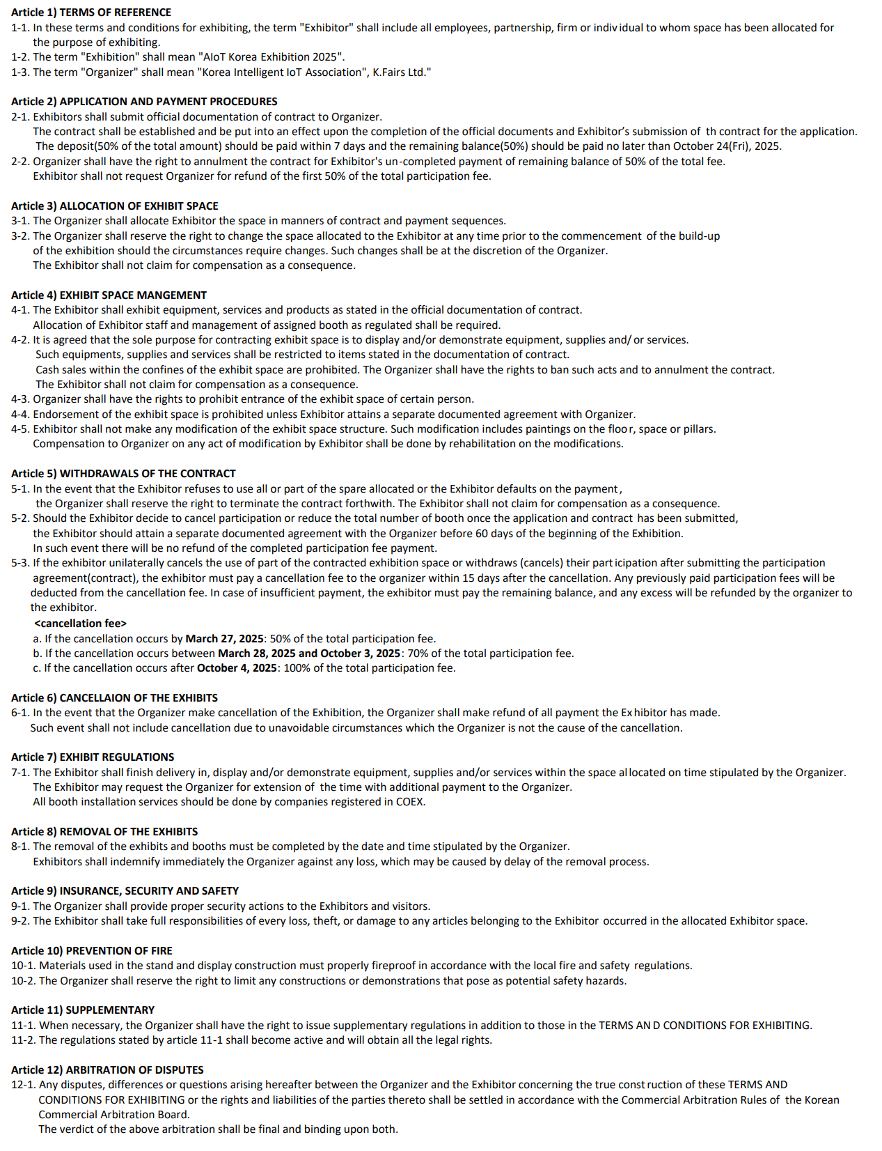

AIoT Korea Show Management Office l T. +82-2-555-7153 E. aiot@kiot.or.kr